GAD323 Readings & Assignments: Week 3
Week 3 Reading
Complete the following reading early in the week:
- Read Week 3 online lectures
- The following chapters from the text The Elements of Cinema, by Stefan Sharff:
  - Chapter 1: Introduction
  - Chapter 4: Separation
  - Chapter 5: Parallel Action
- Watch Alfred Hitchcock's Psycho
Week 3 Assignments Overview
Assignment Summary 3: | Due Date
Assignment 1: Discussion Questions | Saturday, May 30, 2009
Assignment 2: Cinematic Analysis | Saturday, May 30, 2009
Assignment 3: Final Project: Storyboard for the Layout Package | Sunday, May 31, 2009
Assignment 4: Critique | Monday, June 1, 2009
Remember that all assignment details can be found on the assignment pages located throughout the week. Go to those specific pages for direction on how to complete each individual assignment.

Week 3 Overview
When Bill Clinton and the Cuban leader Fidel Castro shook hands at the United Nations, the New York Daily News was the only newspaper to capture the first meeting.
There was only one catch, the photo had never been taken. It was a montage, a composite of two pictures that were combined to illustrate a moment that reporters had witnessed but photographers hadn't captured.
The technique of montage is not a new one. Ever since the dawn of photography, people have manipulated images. Today, montage or editing has expanded to include text, sound, and digital presentations; it is possible to place television newscasters in front of breaking news footage and make pop stars jive with animations in music videos.
This week we'll explore montage as a tool of continuity. But that's not all. You'll also learn to create cinematic structures within your scenes to build the illusion of space. Let's get started!

Learning Outcomes:
- Critically evaluate video games.
- Create a complex animation storyboard according to specific game definitions.
- Acquire knowledge and information necessary to accomplish a professional product through reference and research.
- Demonstrate the use of correct terminology and formats associated with preproduction instructions.
- Keep an Idea Journal and sketchbooks in preparation for thumbnails and model sheets for all projects to establish professional preplanning skills.

Cinematic Editing
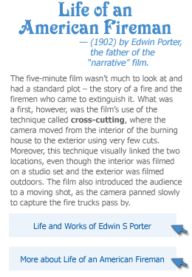
Today the visual language of cinema is one that people and cultures across the world can read and identify with. Most of us have grown up watching films, television sitcoms, commercials, documentaries, and other forms of video presentations. What we see on the screen is a collection of random scenes that individually may not have any meaning. However when viewed together our mind knits them into a cohesive and credible story and space. But it's not always been like this.

In the early days of film-making, the possibilities and potential of the medium remained largely unexplored. Most productions were shot as if the audience were sitting at a theatre production, with straight-ahead camera shots and little, if any, editing. Gradually directors began to realize they could use many other creative techniques in cinematic productions. Different angles and types of camera shots were added. The close-up shot made it possible to show subtle internal states rather than just broad stage acting. Directors also discovered that they could link two unrelated scenes to make sense.

Here's an example: think of the shot of a woman tied to railroad tracks, and juxtapose it with an image of a man riding a horse at top speed. Your mind believes that that the man is riding his horse to save the woman from the oncoming train, even though both shots were filmed at completely different times and on different locations. This exponentially expanded the possibilities of film as directors could show a synchronicity between location and time to create a causal relationship.

Nowhere was this illustrated better than in Life of an American Fireman (1902) by Edwin Porter, the father of the "narrative" film. Look at the graphic on the sidebar to know more about the film.

Pioneers – Edwin S. Porter
http://www.earlycinema.com/pioneers/porter_bio.html


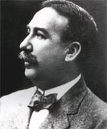
Edwin S. Porter joined the Vitascope Marketing Company in 1895 where his experience with electrical engineering was called into use.

Whilst at Vitascope, Porter was central in the organisation of the first projected movie show in New York on the 23rd April 1896. He continued to use his engineering skills in the laboratory at Edison’s Manufacturing Company but left to become a freelance projectionist at the Eden Musee Theatre in 1898.

Whilst working as a projectionist, one of Porter’s many duties included the illegal duplication of Méliès films. He would take apart one act reels and combine several of these into a fifteen minute programme.

In addition, he attempted to create his own camera and projector but his efforts were in vain and in 1900 he returned to Edison’s Company not in an engineering capacity but as a producer and director at Edison’s East 21st Street Skylight studio.
A fan of the films of Georges Méliès, Porter tried to emulate the trick photography which Méliès had introduced to the world and had proved incredibly successful, in films such as 'The Finish of Bridget McKeen' (1901) and 'Jack and the Beanstalk' (1902). Porter was also one of the first directors to shoot at night in his 'Pan-American Exposition by Night'.

Porter’s skill with editing and methods of projection were used to great effect in some of his earliest films. He combined documentary footage with his own footage in films like 'The Execution of Czoyosz' (which he made with actor and set painter George S. Fleming); in 'Life of an American Fireman' he adopted a documentary style of filmmaking .
top

'Life of an American Fireman' combined stock actuality footage of fires, firemen and fire engines with dramatised scenes which Porter shot, this juxtaposition added tension and release to the film making it truly dramatic in contemporary setting, unlike Méliès whose filmatic drama was derived from his films’ fantasy settings.
Porter was convinced, from the audience reaction that he had discovered a new way of telling stories and developed his ideas the following year with the release of 'The Great Train Robbery', perhaps the most influential film of that decade.

'The Great Train Robbery' benefited from a strong storyline, well composed, sophisticated camera work and an excellent climax, joined together by Porter’s excellent use of editing.
Although it was not the first 'Western', 'The Great Train Robbery' was the first Epic Western, which boasted a cast of forty actors working to an actual script.

During his time at Edison, he made many films for the company, in fact he was the mainstay of their film production for over five years. He left in 1909 and took senior production posts with a number of new independent companies.
Six years later, In 1915 Porter returned to his firs enthusiasm - projectors and remained involved with projection for the rest of his working life.

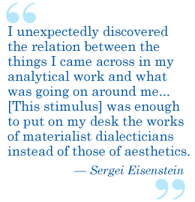
The next revolution in editing came in 1925 in Russia. A man by the name of Sergei Mikhaylovich Eisenstein developed a theory of montage that he illustrated in four films, most notably Battleship Potemkin. This film contains the famous Odessa Steps sequence that has often been imitated and discussed throughout film history.
The concept of montage was introduced for the first time as the juxtaposing of two film images to produce a new idea. To illustrate the idea in films, Eisenstein used a theatrical device called the "montage of attractions," throwing shocking, spectacular scenes at an audience. In his film Strike, he went much further. The film was extremely well received, though some critics objected to its "eccentricity."
Eisenstein wrote extensively about his approach to montage. He identified five separate types of editing: the metric, the rhythmic, the tonal, the overtonal, and the intellectual.
Metric editing is based on the duration of each shot, and the proportional relationship of duration between shots. The example cited earlier of the cross-cutting between the woman tied to the railroad tracks and the man riding a horse is an instance of metric montage. As he gets closer to her, the shots become faster, creating a mounting tension.
Rhythmic montage is an elaboration of metric, in which the movement within the frame is taken into consideration along with the metric concerns. Cutting from a wide shot to a close-up shot of a person sitting in a chair, would be a form of rhythmic montage (the edit is based on the movement within the frame of the person sitting down).
Tonal montage is based on the emotional timbre of the shot or group of shots as a basis for editing. Sad scenes tend to have slower editing paces than action scenes. Overtonal montage is a synthesis of the metric, the rhythmic, and the tonal forms of editing, though primarily a theoretical concept. Eisenstein saw this as a form of editing that was only visible in the projection when the "overtones" were visible.
Eisenstein is best known for the form of editing called intellectual montage. In the intellectual cut, two scenes are juxtaposed to create a meaning that is more than the two individual shots. In Strike, Eisenstein made an ideological commentary on the policies of czarist Russia by showing the government massacring workers and then cutting to a shot of an ox that had been slaughtered.
Using the navigation on the left, please proceed to the next page.

http://www.filmlinc.com/archive/nyff/strike.htm

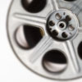 | the films of  the 36th new york film festival:  at the walter reade theater  eisenstein's strike  October 1, 1998  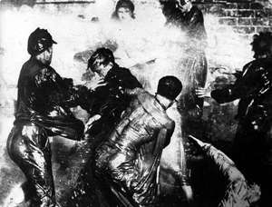    STRIKE

Celebrating the 100th anniversary of Sergei Eisenstein's birth
The 36th New York Film Film Festival presents STRIKE
USSR,1924; 92 minutes, silent, new 35mm print
new score composed and performed by The Alloy Orchestra
Thursday, October 1: 7 and 9:30 pm at the Walter Reade Theater.
Admission: $12
In Sergei Eisenstein's first feature film, the suicide of a fired factory worker sets off an initially peaceful strike, which Russian Cossacks eventually "settle" by slaughtering the workers. Set in 1912, STRIKE stars members of the radical Proletkult Theater and shows Eisenstein putting into play for the first time his pioneering theory of "dialectical montage."
A brilliant cinematic essay on breaking all the rules of moviemaking, STRIKE is a powerful example of Russian Constructivism, an avant-garde movement driven by revolution, the language of the masses, modernity, and utopian visions. Technology gives Constructivism its forms; structure, geometry and movement characterize its style. Eisenstein's editorial/poetic shock tactics are viscerally in evidence, as when he cuts ever more swiftly from a descending butcher's knife to shots of the Cossack massacre to the throat of a bull being slit. STRIKE is filmmaking being invented before your very eyes!
The silent film program at the Walter Reade Theater is made possible through the generosity of the Ira M. Resnick Foundation.

Cinematic Syntax One: The Cinematic Space
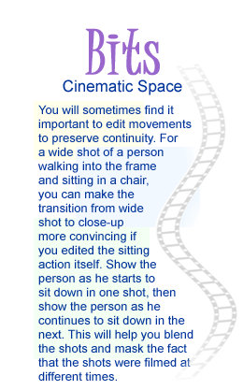
You already know that editing refers to the selection and ordering of shots to create a narrative structure that communicates ideas, feelings or attitudes. Although editing is essentially a stage in the post-production phase, planning a narrative sequence will help you avoid redundancy while you take on the actual filming of the production.
Whether in films, animations, or video games, all narratives depend on a chain of visual impressions that move as well as interlock with each other. The laws that govern the organization of elements into such a dynamic flow of impressions are collectively known as cinematic syntax.
One such element of cinematic syntax is the use of cinematic space, which creates a world of cinematic illusion on the screen.
It is possible to divide cinematic space into several different approaches—separation, parallel action, familiar image, slow disclosure, multi-angularity, and the master shot discipline. Not every production necessarily uses every one of these processes, but taken together, they constitute the realm of possibilities in creating a believable space in cinema.
Separation, or the most common cinematic use of space, involves breaking a scene into pieces. If you want to shoot two people talking to one another across a table, separation would include the individual close-ups that make up the scene. These instructions should be mentioned in the storyboard itself to help the director while shooting. The decision will be taken by director but you can also put your perspective through the storyboard.
Separation works best when each character or focus is weighted on one side of the frame and there is a close-up of each frame. The intercutting between the two frames creates a visual balance that forms a believable space of the two people in conversation. As you learned in last week's lectures about "crossing the line," separation works best when the focus in each frame is equally weighted. In the scenario of two people talking across a table, separation is created by eyelines in each frame that seemingly look toward the other frame.
Remember the action of the horse rider cut with the woman tied to the railroad tracks? That was an example of parallel action, a formal term used to describe cross-cutting.
A familiar image is a repeated image that you can use in various ways. For example, in a scene involving two men arguing, you might include an occasional shot of a dog looking back and forth as if to follow the action. Here you would be using a familiar image as a cutaway to diversify the shots in the scene. You can also repeat a familiar image through your scenes to foreshadow an important part of the plot, or as an important part of the resolution of a sequence.
Slow disclosure refers to a sequence that uses small fragments of visual information to lead up to something not initially seen on screen. If you create a series of close-ups that become wider as the scene progresses, you would be resorting to slow disclosure. Each shot shows a little more information until the final shot reveals the unseen source of the previous sequence. You can use this method to create a feeling of suspense.
The master shot technique is the most common shot used in studio films. In this method you can begin each scene with a wide shot, and move progressively into closer frames as the scene unfolds. You can then use alternating close-ups and medium shots as the scene plays out. At the end of the scene, return to a wide shot. You can use the master shot approach as a safe way to move into and out of a scene, but guard against monotony.

Conclusion
Editing affects the way we see a cinematic space, but it isn't always the final word. While rules are necessary to create a cinematic space, they should be constantly tested and expanded. However, you must know the rules before you can break them. The lectures this week introduced some of the most important cinematic rules, and act as a springboard for you to create your own visual language. Once you begin to understand the concepts of cinematic space and editing, you will be better able to plan your productions.
And though it's immensely useful to master cinematic editing and space structures, it is also very useful to learn where and why they were first used, and how they changed the cinematic medium forever. We hope this week's lectures have been helpful in unveiling these intriguing histories to you.

Assignment 1: Discussion Questions
By Saturday, May 30, 2009, go to the Discussion Area and post responses to 2 of the discussion questions assigned by the facilitator. All discussion questions should be posted to the appropriate Discussion Area.
Before the end of the week, begin commenting on at least 2 of your peers' responses. You can ask technical questions or respond generally to the overall experience. Be objective, clear, and concise. Always use constructive language, even in criticism, to work toward the goal of positive progress. Submit your responses to the appropriate topic in this Discussion Area.
Assignment 1 Grading Criteria and Respective Point Value: | Maximum  Points
Response Criteria
Met the criteria for the correct responses to the questions assigned. | 4
Used vocabulary relevant to the current week's topics—at least four terms. | 4
Participation Criteria
Used vocabulary relevant to the current week's topics—at least four terms. | 4
Participated in the discussion by asking a question, providing a statement of clarification, providing a point of view with rationale, challenging a point of discussion, or making a relationship between one or more points of the discussion. | 4
Justified ideas and responses by using appropriate examples and references from texts, Web sites, and other references or personal experience. | 4
Total: | 20
For assistance with any problems you may have when completing this assignment—OR—to offer your assistance to classmates, please use the Problems and Solutions Discussion area located through the left side navigation link.
After reading the lectures, discuss what you learned and how it will relate to your storyboards.
Due date is Saturday so take your time.
Point values---
10 points for the DQ
10 points for responding to 2
Check this out!
http://alsolikelife.com/shooting/2009/01/953-95-heimat-1984-edgar-reitz/

Assignment 2: Cinematic Analysis
View Alfred Hitchcock's Psycho and note the sequence at the beginning of the film when the woman gets pulled over by the police. (If you have difficulty finding a copy of the movie locally, try one of the following: You may purchase a streaming copy at http://www.cinemanow.com/433,0,0,0,0,0,11658/Psycho-1960-.htm or go to DVD.com to rent. ) Analyze the sequence based on the following attributes:
- Narrative structure
- Editing
- Shot composition
- Aesthetics
- Continuity
Post your views to this Discussion Area by Saturday, May 30, 2009. Review and critique the work of at least two other students early in the week.
Assignment 2 Grading Criteria and Respective Point Value: | Maximum  Points
Critically analyzed cinematic elements and their relationship to content. | 4
Critically observed technical aspects of visual narrative, including shot composition, continuity, and editing (3 X 4 points for each aspect). | 12
Provided meaningful comments to two other students (2 x 4 points). | 4
Total: | 20
For assistance with any problems you may have when completing this assignment—OR—to offer your assistance to classmates, please use the Problems and Solutions Discussion area located through the left side navigation link.
This should be really fun...includes extra credit
10 points:
sketch 3 consecutive shots
use shading to convey lights and darks
color is optional
include the camera directives and director cues under the image
post like this:
w3a2_lastname_psycho.jpg
New Due Date:
Monday before midnight eastern

Assignment 3: Layout Package—Final Project Storyboard
Storyboard the script that you developed as part of your Week 1 assignments using at least two cinematic elements that you've studied from continuity, weighting in the frame, eyelines, cutting on movement, parallel action, familiar image, slow disclosure, and/or the master shot discipline. The storyboard panelsshould be complete with detailed camera directions and dialogue notated undereach panel. Save the storyboard panels in the JPEG format and post them to this Discussion Area by Sunday, May 31, 2009.
Assignment 3 Grading Criteria and Respective Point Value: | Maximum  Points
Created a dynamic storyboard with proper staging, continuity between frames,and eyelines between characters. | 4
Used cinematic elements like camera movement, parallel action, slowdisclosure, cutaways appropriately to present the storyboard (4 x 4 pointsfor each cinematic element). | 16
Adhered to the basic design proposed in the script. | 4
Composed the frame and the action in depth with details. | 4
Total: | 28
For assistance with any problems you may have when completing this assignment—OR—to offer your assistance to classmates, please use the Problems and Solutions Discussion area located through the left side navigation link.
New Due Date:
Tuesday for the board
Wednesday for the critique

Critique 1: choose someone who has not been critiqued, if possible, so everyone gets one.
Compare the proposal with the board.
Comment on treatment of:
narrative structure,
editing,
how they have used camera placement,
shot composition,
separation,
staging to enhance their storyboard.
Provide feedback on how these elements could be used to improve their storyboards.

First:
Create the board---you must use the technicals posted lower in the thread---so we are all on the same page.
bottom left = angles
middle = movement
botto right = director cues
label like this:
w3a3_lastname_board.jpg
Second:
Post the script/written version in the thread and attach the board to the same thread.
Third:
Critique one peer using the guidelines posted above

Who wants to define these for the golden chicken award?:
weighting in the frame
eyelines
cutting on movement
parallel action
familiar image
slow disclosure
the master shot discipline

Use the board.jpg for the template

Use these technicals only:
Camera Movements and Director Cues.
Name your shots like this:
For Angles,
extreme close-up (ECU) fills the lens with the subject as close as possible
medium close-up (MCU) is the same thing but not quite as tight on the subject.
medium shot (MS) generally will include the head and shoulders in the shot. When more than one person is on camera the shot is referred to as a 2 Shot or 3 Shot, whatever the case may be.
wide shot (WS) will usually include the entire character from head to toe.
extreme wide shot (EWS) is a panorama that may include mountains, city skylines, and other camera views that cover vast amounts of space.
Movements,
PAN is a shot in which the camera, set in a fixed position and mounted on a tripod, rotates to follow the action horizontally.
DOLLY MOVE, the camera moves on wheels along side the action, or forward and away from the action.
TILT is similar to a PAN; only the camera rotates in a vertical direction.
PED move or crane shot is similar to a DOLLY MOVE, but the camera movement is vertical as well.
ZOOM of course is racking the lens in or out on the subject.
Director Cues,
establishing shots are done with a fade in (FI), which goes from black to full resolution in a prescribed time frame.
the reverse is true in a fade out (FO).
the dissolve (DIS), sometimes called a lap dissolve or cross dissolve blends from one scene into another.
a cut (CUT) is not the end of the scene but the end of a particular shot, an indication that camera should switch to another angle.
positioning of cameras can also go to extremes, such as a worm's eye view (extremely low angle) or a bird's eye view (extremely high angle).

See example storyboards in the week 3 directory

Template:
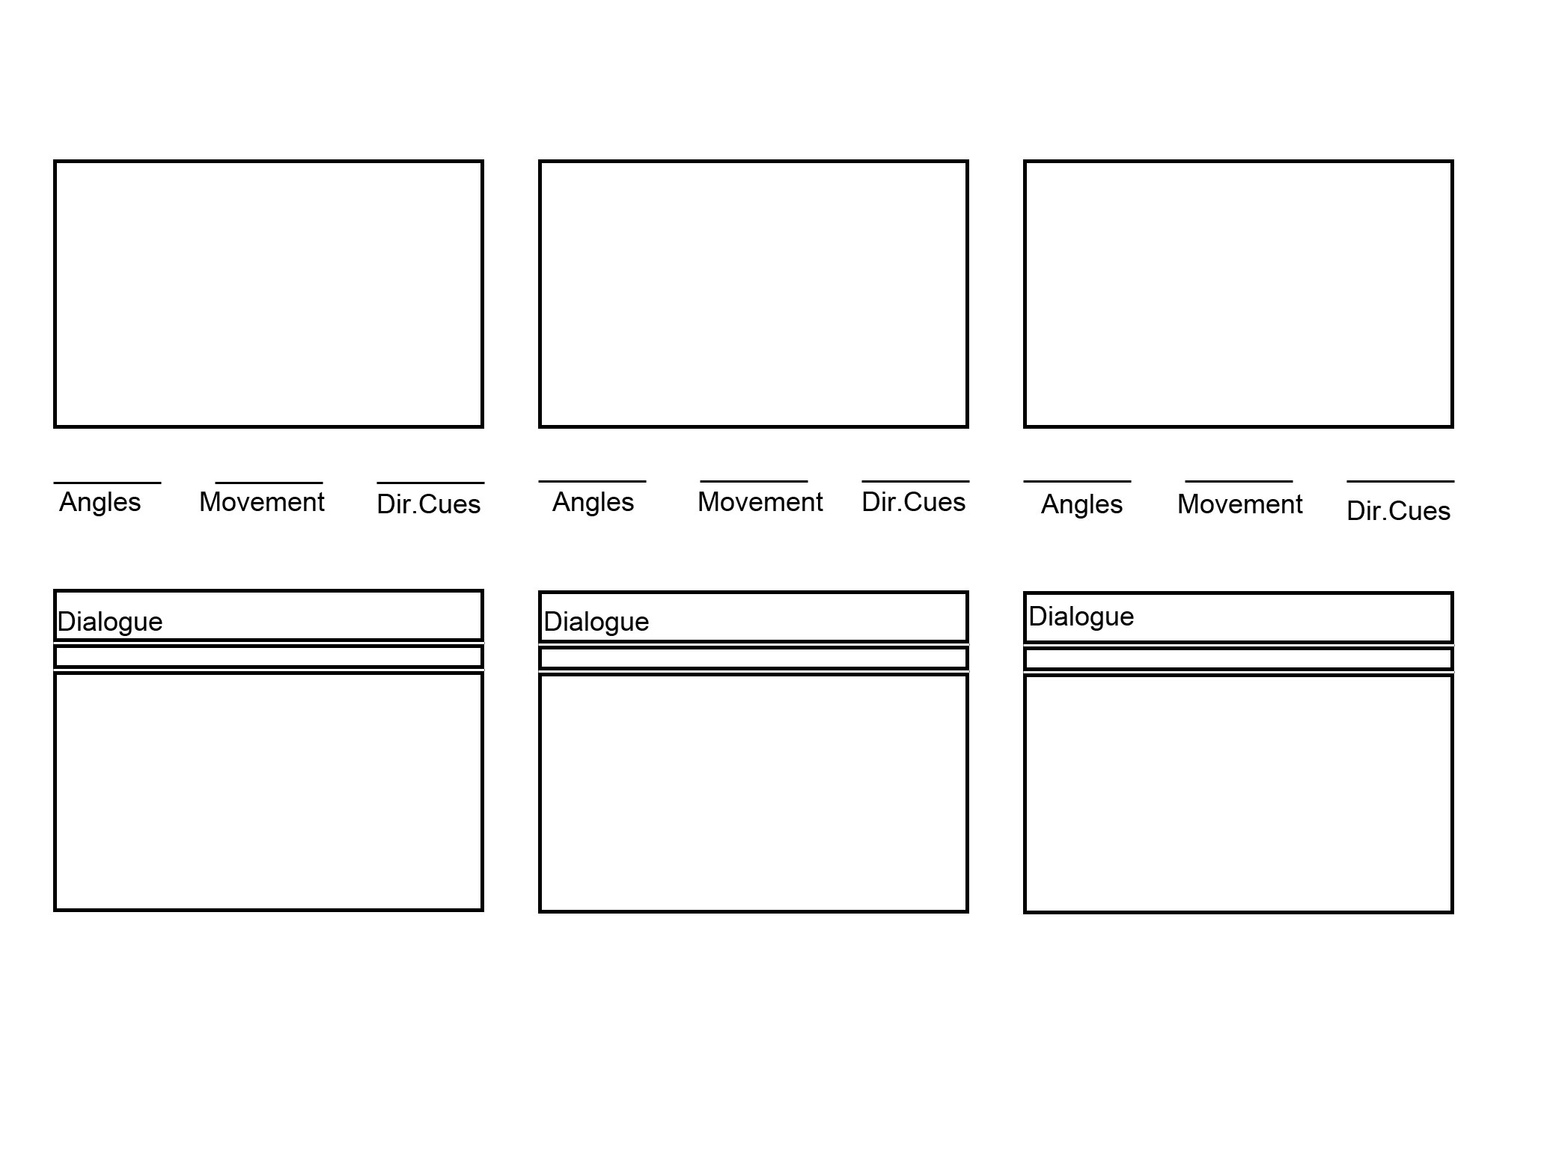
Assignment 4: Critique
Refer to the storyboard proposal submitted by two of your peers in the first week and review their storyboard in the context. Comment on treatment of narrative structure, editing, and how they have used camera placement, shot composition, separation, and staging to enhance their storyboard. Provide feedback on how these elements could be used to improve their storyboards. Post your feedback and views to this Discussion Area by Monday, June 1, 2009.
Use the feedback received from your peers to improve your storyboard. You will need to submit your revised storyboard next week.

Assignment 4 Grading Criteria and Respective Point Value: | Maximum  Points
Used game art design vocabulary. | 4
Commented on the editing in the storyboard. | 4
Commented on the narrative structure in the storyboard. | 4
Commented on how elements such as camera placement, shot composition, separation, and staging have enhanced the storyboard (4 x 4 points for each element). | 16
Justified ideas and responses by using appropriate examples and references to readings. | 4
Total: | 32
For assistance with any problems you may have when completing this assignment—OR—to offer your assistance to classmates, please use the Problems and Solutions Discussion area located through the left side navigation link.

